PROJECT REPORT
CLOUD ARCHITECTURE DESIGN – AWS CLOUD PROJECT

PROJECT TITLE
AI-Based Multi-Cloud Migration Decision Framework for Healthcare Enterprises using Multi-Criteria Decision Intelligence

Submitted by: Charles (24BIT0522), Tanmay Kapoor (24BIT0079), Rani Gupta (24BIT0543)
Programme / Branch / Year: BTech. / Information Technology / 3rd
Course Code and Name: BCSE355L – Cloud Architecture Design
Institution: Vellore Institute of Technology, Vellore
Course Instructor / Guide: Dr. Priya V
Team Number: 11
GitHub Repository: https://github.com/itscharles4/AI-Based-Multi-Cloud-Migration-Decision-Framework-for-Healthcare-Enterprises
Date of Submission: 10/16/2026

Abstract
Hospitals now use Internet of Medical Things (IoMT) devices that stream patient vital signs continuously, and every reading must be processed either on a local edge server or in the cloud. Existing systems rely on static, reactive rules: they react only after the network has degraded, treat urgent and routine data alike, ignore cost, and expose sensitive health data to public-network risk. This project proposes an AI-based decision framework that predicts network degradation before it happens and routes each reading to the edge or the cloud using Multi-Criteria Decision Intelligence. A two-layer stacked LSTM forecasts the next network latency from a window of 20 readings and was trained on 2,830,022 real RIPE Atlas measurements. An Analytic Hierarchy Process (AHP) engine then weighs patient criticality (0.6396), predicted latency (0.2583) and cloud cost (0.1021), with a consistency ratio of 0.037, after two hard safety vetoes that always force edge processing when criticality is at least 9.0 or predicted latency is at least 300 ms. Emergency routing triggers Telegram and e-mail alerts, every decision is written to a SHA-256 hash-chained audit log, and a web dashboard shows live routing results. The target AWS architecture uses IoT Core, IoT Greengrass, Lambda, SageMaker, API Gateway, DynamoDB, S3, SNS, Cognito, IAM, CloudWatch and QuickSight. Status: the complete pipeline is implemented and tested locally with stand-ins for these services, 99 automated tests are reported passing in continuous integration, and the dashboard has processed 518 simulated events. AWS deployment, measured accuracy against baselines and formal load testing are planned and not yet completed. The work is a research prototype that uses simulated and public data only; it follows HIPAA-aligned design principles but is not certified or clinically validated.

Keywords
AWS, edge–cloud offloading, serverless computing, LSTM latency forecasting, Analytic Hierarchy Process, healthcare IoMT

Table of Content
- 1. Introduction
- 2. Literature Survey / Related Work
- 3. Research Gap Analysis
- 4. Project Objectives
- 5. Novelty Summary
- 6. Proposed System and Architecture
- 7. Dataset Description
- 8. AWS Services Planning
- 9. Methodology and Implementation Plan
- 10. Implementation / Development
- 11. Testing, Results and Observations
- 12. Discussion, Limitations and Risk Analysis
- 13. Team Contribution and GitHub Management
- 14. Conclusion and Future Enhancements
- References
- Appendix A – Project Timeline
- Appendix B – Review Checklist

1. Introduction

1.1 Background
Telemedicine and Internet of Medical Things (IoMT) devices such as ECG monitors, pulse oximeters, blood-pressure sensors, temperature sensors and respiratory monitors produce continuous streams of patient vital signs. In an intensive-care setting every device may send a reading every few seconds, and each reading has a different urgency. Cloud computing offers elastic capacity, managed storage and pay-per-use pricing, but a cloud round trip adds network delay and depends on the hospital connection staying healthy. Edge servers inside the hospital are faster and keep data local, but their capacity is limited [11]. A cloud architecture therefore has to decide, reading by reading, where processing should happen.
Amazon Web Services (AWS) provides the building blocks for such a hybrid design: AWS IoT Core and IoT Greengrass for device ingestion and local execution, Lambda for event-driven processing, SageMaker for machine-learning models, and DynamoDB, S3, SNS, Cognito, IAM and CloudWatch for storage, notification, security and monitoring [21]–[24].

1.2 Problem Statement
The specific problem is to decide, for every IoMT reading, whether to process it at the hospital edge or in the cloud. Three situations show why one fixed rule fails. A patient in cardiac arrest (criticality 9.8 out of 10) cannot tolerate hundreds of milliseconds of cloud delay. A routine check (criticality 1.2) is safe and cheaper in the cloud. When the network degrades, for example 14% packet loss and latency above 300 ms, even low-risk data should stay local because the cloud path is unreliable.
Hospital IT teams and clinicians are the affected stakeholders. Current practice relies on static rules set by administrators. These rules react only after a link has failed, ignore cost, treat urgent and routine data alike, and send sensitive health data over public networks, which creates compliance risk [13]. Existing research offers forecasting without routing [1], [3], offloading with fixed priority rules [10] or black-box reinforcement learning [4], [7], [9], and compliance frameworks without automated enforcement [13].

1.3 Motivation and Significance
Healthcare data volumes keep growing, delays and outages affect patient safety, and cloud cost grows with unnecessary processing. A predictive, explainable and auditable routing decision gives hospitals faster critical alerts, lower cloud spend on routine data and a record that can be reviewed afterwards. The project also provides a practical, low-cost way to learn and demonstrate AWS serverless and hybrid architecture patterns.

1.4 Scope
Included: network-latency forecasting with an LSTM; a two-stage multi-criteria routing engine (hard safety vetoes and AHP scoring); an execution layer with edge and cloud nodes; REST and MQTT ingestion; relational storage; JWT authentication with role-based access; Telegram and e-mail alerts; a hash-chained audit log; a monitoring dashboard; automated tests and continuous integration; and a design that maps every component to a named AWS service.
Excluded: deployment in a real hospital, use of real patient data (only simulated and public de-identified data are used), clinical validation of the criticality score, and HIPAA certification. The full AWS deployment is planned future work. AWS is the target provider; choosing between several cloud providers is left as an extension because the AHP criteria can be extended to further alternatives.

1.5 Report Organisation
Chapter 2 reviews 15 research papers and the research gap. Chapter 3 states the objectives and Chapter 4 the novelty. Chapter 5 presents the architecture, Chapter 6 the datasets and Chapter 7 the AWS services. Chapter 8 describes the methodology, Chapter 9 the implementation with evidence, and Chapter 10 the tests and results. Chapter 11 discusses limitations and risks, Chapter 12 documents team contribution and GitHub management, and Chapter 13 concludes with future work. References and two appendices (timeline and checklist) follow.

2. Literature Survey / Related Work
The table lists the 15 reviewed papers (P1–P5 Charles, P6–P10 Tanmay Kapoor, P11–P15 Rani Gupta). Fields marked in yellow, such as authors and DOI, must be completed from the publisher record before submission.
Paper ID | Full citation / DOI / URL | Problem addressed | Method / architecture | Dataset / evaluation | Key findings
P1 | Deep Learning for Network Congestion Prediction in Healthcare IoT. IEEE, 2025. authors, volume/pages, DOI | Predicting network congestion and bandwidth drops in healthcare IoT | LSTM-based time-series forecasting | 5G network traces; accuracy of bandwidth-drop prediction | High accuracy in predicting bandwidth drops (under 10 ms reported); costly to run the model continuously in the cloud.
P2 | Edge-AI in Remote Patient Monitoring Systems. Elsevier, 2024. authors, volume/pages, DOI | Reducing data sent from remote patient monitoring | Federated Edge Learning (FELL) | MIMIC-III vitals | Reduces data transmission overhead by 40%.
P3 | Spatiotemporal Forecasting for Hospital Wi-Fi Reliability. Springer, 2026. authors, volume/pages, DOI | Predicting Wi-Fi reliability and dead zones inside hospitals | Graph Convolutional Networks (GCN) | Enterprise Wi-Fi logs | Maps physical hospital dead zones effectively; struggles with sudden, unpredictable anomaly spikes.
P4 | Energy-Efficient AI Workload Offloading in Wearables. MDPI, 2025. authors, volume/pages, DOI | Offloading AI workloads from medical wearables to save energy | Deep Reinforcement Learning (DRL) | IoMT sensor data | Maximises battery life of medical wearables; decisions are a black box.
P5 | Traffic Classification of Telemedicine Video Streams. IEEE, 2023. authors, volume/pages, DOI | Telling emergency video feeds from routine calls | CNNs on packet headers | Telehealth video packets | Quickly separates emergency feeds from routine calls; privacy risk if payloads are inspected.
P6 | A framework for offloading and migration of serverless functions in the Edge–Cloud Continuum. Elsevier, 2024. authors, volume/pages, DOI | General offloading and migration of serverless functions between edge and cloud | Serverledge framework with horizontal and vertical function offloading and migration | Experimental evaluation on an edge-cloud testbed | Supports live migration and decentralised scheduling with better utilisation; not healthcare-aware and has no decision intelligence.
P7 | Energy-Aware Tasks Offloading Based on DQN in Medical Mobile Devices. Springer, 2024. authors, volume/pages, DOI | Reducing delay and energy when offloading tasks from medical mobile devices | Deep Q-Network (DQN) task offloading | Medical mobile device simulation | Reduces execution delay and energy; high training complexity and limited scalability evaluation.
P8 | Resource Allocation and Data Offloading Strategy for Edge-Computing-Assisted Intelligent Telemedicine System. MDPI, 2023. authors, volume/pages, DOI | Allocating resources and offloading data in edge-assisted telemedicine | Resource allocation and computation-offloading optimisation | Wireless Body Area Network (WBAN) simulation | Improves transmission efficiency and reduces latency; security and privacy are minimally addressed.
P9 | DRL-Based Dependent Task Offloading with Delay-Energy Trade-off in Medical Image Edge Computing. 2025. publisher / venue missing in Review 1; authors, DOI | Offloading dependent tasks of medical-image processing | Deep Reinforcement Learning (DRL) | Medical image processing simulation | Balances delay and energy for dependent tasks; tested mainly on imaging workloads.
P10 | Towards providing a priority-based vital sign offloading in healthcare with serverless computing and a fog-cloud architecture (SmartVSO). Elsevier, 2024. authors, volume/pages, DOI | Prioritised offloading of vital-sign data | Priority-based workload offloading on a serverless fog-cloud architecture | Simulated smartwatch vital-sign data under different workloads | Low latency for critical patients and scalable serverless deployment; priority rules are static and not AI-based.
P11 | Performance Analysis of Edge … title, publisher and year are incomplete in Review 1; complete from the source | Comparing edge and cloud processing latency for local sensor networks | Empirical latency testing | Local sensor-to-edge-core measurements | Edge processing is about ten times faster than the cloud for local networks; does not address syncing edge data back to the cloud.
P12 | Cold Start Mitigation in Serverless Functions for Healthcare APIs. ACM, 2026. authors, volume/pages, DOI | Reducing cold-start delay of serverless healthcare APIs | Concurrency tuning | Serverless API traces | Reduces Lambda cold starts to under 50 ms; provisioned concurrency is expensive to keep running 24/7.
P13 | HIPAA-Compliant Architectures in Multi-Cloud Environments. Springer, 2024. authors, volume/pages, DOI | Mapping HIPAA requirements to multi-cloud architectures | Framework design and mapping | Regulatory rulebooks | Comprehensive security guidelines for PHI; abstract, with no automated enforcement tools.
P14 | Blockchain vs. Serverless for EHR Access Logs. Elsevier, 2025. authors, volume/pages, DOI | Choosing an architecture for tamper-resistant EHR access logs | Comparative architecture review | Simulated EHR queries | High integrity for audit trails, but blockchain is too slow for real-time IoMT telemetry.
P15 | Scalability of Microservices in Telehealth Platforms. Wiley, 2026. authors, volume/pages, DOI | Scaling telehealth platforms with microservices | Kubernetes (EKS) stress testing | Video consultation data | Highly scalable for heavy video processing; overkill and complex for lightweight sensor telemetry.

2.1 Synthesis and Comparison
By approach, the papers fall into five groups. Forecasting papers [1], [3] predict network problems with LSTM and graph networks but stop at prediction; they do not decide where the workload should run. Offloading papers [4], [7], [9] use reinforcement-learning variants that save energy or delay but act as black boxes and were tested mostly in simulation. Serverless and edge-cloud papers [6], [10], [12], [15] show that serverless functions can be migrated, prioritised and scaled, but their priority rules are static or not healthcare-aware, and [15] finds container orchestration heavy for light sensor telemetry. Edge and federated papers [2], [11] show that processing near the source cuts latency (about ten times in [11]) and data transfer (40% in [2]) but leave synchronisation back to the cloud open. Security papers [8], [13], [14] and the traffic-classification paper [5] show that privacy and audit are treated only abstractly, and that blockchain is too slow for telemetry [14].
Common trends are the use of simulations and small test beds, latency and energy as the main performance measures, and little attention to cost and compliance. Some findings pull in different directions: edge processing is much faster locally [11], while the serverless papers [12], [15] stress the elasticity and lower operating burden of the cloud. The best placement therefore depends on the situation, which motivates deciding dynamically for each reading rather than choosing one location in advance.

2.2 Individual Research Gap Analysis
Analyses were prepared by the student assigned to each paper: Charles (P1–P5), Tanmay Kapoor (P6–P10) and Rani Gupta (P11–P15).
Paper ID | Existing method | Advantages | Limitations | Research gap identified by student | Possible improvement
P1 | LSTM time-series forecasting | Accurate prediction of bandwidth drops | Costly to run continuously in the cloud | Lightweight AI is needed that can trigger local edge processing before the cloud connection fails | Compress the forecaster and run it at the edge (Greengrass), using the cloud model only for retraining
P2 | Federated edge learning | Cuts transmission overhead by 40% | Ignores dynamic pricing of cloud failover under heavy traffic | AI must work with cost-aware decision engines, not only latency-aware models | Add cloud cost as a decision criterion (AHP cost weight) beside latency
P3 | Graph convolutional networks | Maps hospital dead zones | Struggles with sudden, unpredictable anomaly spikes | Network prediction must be paired with instant anomaly handling to trigger immediate edge failover | Add a hard predicted-latency veto and a rolling anomaly check that routes to the edge at once
P4 | Deep reinforcement learning | Maximises wearable battery life | Black-box decisions; poor explainability for medical IT audits | Mathematical MCDM models are more transparent for clinical compliance than pure DRL | Use AHP with published weights and a consistency ratio, and log every decision with its scores
P5 | CNNs on packet headers | Quickly tells emergency video from routine calls | Privacy risk if packet payloads are inspected | Payload-blind AI is needed to keep HIPAA-style protection during classification | Use only metadata (device ID, latency, criticality score) and never store payloads or patient identifiers
P6 | Serverledge offloading and migration | Live migration, decentralised scheduling, better utilisation | General purpose; not healthcare-aware; no decision intelligence | No medical workload prioritisation or telemedicine-specific backend logic | Add a healthcare workload classifier and an MCDM-driven migration policy
P7 | DQN task offloading | Lower execution delay and energy use | High computational complexity during training | Scalability to larger networks is not evaluated | Evaluate on large-scale healthcare workloads and reduce training effort
P8 | Resource allocation and offloading optimisation | Better transmission efficiency and lower latency | Security and privacy are minimally addressed | No comprehensive security mechanism for patient data | Integrate stronger encryption and privacy-preserving techniques
P9 | DRL dependent-task offloading | Balances delay and energy for dependent tasks | Tested mainly on medical-imaging workloads | Applicability to broader healthcare services remains unexplored | Evaluate on telemedicine, EHR access and remote monitoring workloads
P10 | Priority-based serverless fog-cloud offloading | Low latency for critical patients; scalable and serverless | Static priority rules; no AI decisions; no cloud provider selection | No intelligent backend that chooses the execution location from several factors at once | Combine AI with an MCDM engine over latency, cost, server load, patient severity and reliability
P11 | Empirical latency testing at the edge | Shows edge processing is about ten times faster for local networks | Does not explain how to sync edge data back to the cloud | A hybrid synchronisation mechanism is needed so edge data reaches long-term cloud storage | Queue edge records and replicate them to S3 and DynamoDB when connectivity returns
P12 | Concurrency tuning | Cold starts under 50 ms | Always-on provisioned concurrency is expensive | Predictive AI should raise Lambda concurrency only when traffic requires it | Use the latency and traffic forecast to scale concurrency ahead of bursts
P13 | HIPAA framework and rule mapping | Comprehensive PHI security guidelines | Abstract; no automated enforcement | Compliance rules must be coded into the routing logic as strict constraints | Encode hard vetoes and data-minimisation rules in the decision engine and audit every decision
P14 | Comparative architecture review | High integrity for audit trails | Blockchain is too slow for real-time IoMT telemetry | Fast serverless logging with secure object storage is a better fit for IoT telemetry | Use an append-only hash-chained log in a database and verify it on demand
P15 | Kubernetes (EKS) stress testing | Highly scalable for video processing | Overkill and complex for lightweight sensor telemetry | Event-driven serverless is more efficient than container orchestration for IoT telemetry | Run the decision logic as event-driven Lambda functions without EC2 or EKS

2.3 Consolidated Research Gap
Across the 15 papers, forecasting work stops at prediction [1], [3], offloading work depends on fixed priority rules [10] or black-box learning [4], [7], [9], and compliance work remains abstract [13], [14]. No reviewed paper combines (a) a forecast of network degradation, (b) a transparent multi-criteria routing decision with hard clinical safety rules and a cost criterion, and (c) a tamper-evident record of every decision in a serverless edge–cloud design. This project addresses that combined gap. The statement is based on the 15 papers reviewed here and is not the result of a systematic literature search.

3. Project Objectives
Objective 1 – Forecast network latency ahead of time: train an LSTM on 2,830,022 real RIPE Atlas measurements to predict the next latency from 20 readings. Success criterion: held-out MAE and RMSE lower than a persistence baseline to be measured and inserted.
Objective 2 – Route every reading automatically with transparent mathematics: implement an AHP engine (criticality 0.6396, latency 0.2583, cost 0.1021) with two hard vetoes. Success criteria: consistency ratio below 0.10 (achieved: 0.037) and 100% of readings with criticality of 9.0 or more, or predicted latency of 300 ms or more, routed to the edge.
Objective 3 – Reduce response time and keep critical data local: keep the 95th-percentile routing response of POST /ingest below 200 ms under load target; load test not yet run.
Objective 4 – Alert clinicians immediately in emergencies: send Telegram and e-mail alerts on every emergency override without delaying the API. Success criterion: delivery recorded for 100% of overrides, within 5 s to be measured.
Objective 5 – Store and audit data securely: use JWT authentication with roles, store no patient identifiers, and keep a SHA-256 hash-chained audit log. Success criterion: altering any stored audit record is detected by chain verification.
Objective 6 – Visualise results and prepare the AWS migration: provide a live dashboard of routing decisions and map every component to an AWS service with a local stand-in. Success criteria: the pipeline runs end to end with one command, 99 automated tests pass in CI, and at least Lambda and S3 are deployed on AWS in the next phase.

3.1 Expected Outcomes
- Trained forecasting model and evaluation graphs: assessed by MAE and RMSE against a baseline (Objective 1).
- Decision engine with tests: assessed by the consistency ratio and routing test cases (Objective 2).
- Execution layer, API and storage: assessed by end-to-end tests and a load test (Objective 3).
- Alert service, authentication and audit log: assessed by delivery logs, role tests and a tamper test (Objectives 4 and 5).
- Dashboard and AWS mapping with Lambda handler: assessed by live demonstration and by deploying selected services in the next phase (Objective 6).
- GitHub repository and documentation: assessed by commits, pull requests and this report (Chapter 12).

4. Novelty Summary
Novelty dimension | Existing approach / limitation | Proposed difference | How it will be demonstrated
New feature | Static, reactive routing rules; forecasting papers stop at prediction [1], [3]; static priority rules [10] | Predictive, context-aware routing: the forecast is used inside the routing decision, with an emergency override and a network veto that lock execution to the edge without human action | Test cases T01–T03 (Chapter 10) and dashboard routing counts (Figures 4–6)
Algorithm / processing | Binary threshold checks, for example latency above 100 ms, or black-box DRL [4], [7], [9] | LSTM forecast plus AHP weighting (consistency ratio 0.037) with hard vetoes; every decision stores its scores and reason | Planned comparison with a threshold baseline on identical events (Section 10.3)
Cloud architecture / AWS integration | All data sent to a central cloud, or heavy container stacks [15] | Serverless edge–cloud design with IoT Core, Greengrass, Lambda and SageMaker; every component has a local stand-in and a named AWS target | Local end-to-end run now; Lambda handler written; AWS deployment, latency and cost test planned
Security / automation / scalability | Limited privacy and abstract compliance rules [8], [13]; blockchain audit too slow [14] | JWT roles, no patient identifiers, SHA-256 audit chain, automatic override, event-driven scaling design | Audit tamper test, role tests, planned load test

The central contribution is a decision framework that joins three things the reviewed papers treat separately: a forecast of network degradation, a transparent multi-criteria routing decision with hard clinical safety rules, and a tamper-evident record of every decision. Routing therefore changes before the network fails, can be explained from stored scores, and can be checked afterwards. The contribution is demonstrated on a working local implementation with an AWS migration path. It has not yet been deployed on AWS or validated in a hospital, and no claim is made that it is the first such system.

5. Proposed System and Architecture

5.1 System Overview
Users and inputs. Hospital IT administrators, doctors and auditors use the system. IoMT devices (ECG, pulse oximeter, blood pressure, temperature, respiratory) are the data sources. Each reading carries network measurements such as latency, packet loss and jitter, and a patient criticality score from 0 to 10, and is sent over MQTT or HTTP.
Processing. (1) The API validates the payload and the caller's JWT. (2) The LSTM [17] predicts the next latency from the last 20 readings and labels the network risk LOW (below 75 ms), MEDIUM (75–150 ms) or HIGH (150 ms or more). (3) The decision engine applies Stage A vetoes and, if none fires, Stage B AHP scoring [16]. (4) The execution layer sends the reading to the edge node (local processing and alert) or the cloud node (routine processing and archive). (5) The decision, its scores and its reason are stored and appended to a hash-chained audit log.
Outputs. Routing decisions in the database, Telegram and e-mail alerts for emergencies, Prometheus metrics, and a dashboard showing counts, latency trends and recent events.

5.2 Diagram 1 – AWS Cloud Architecture (Mandatory)
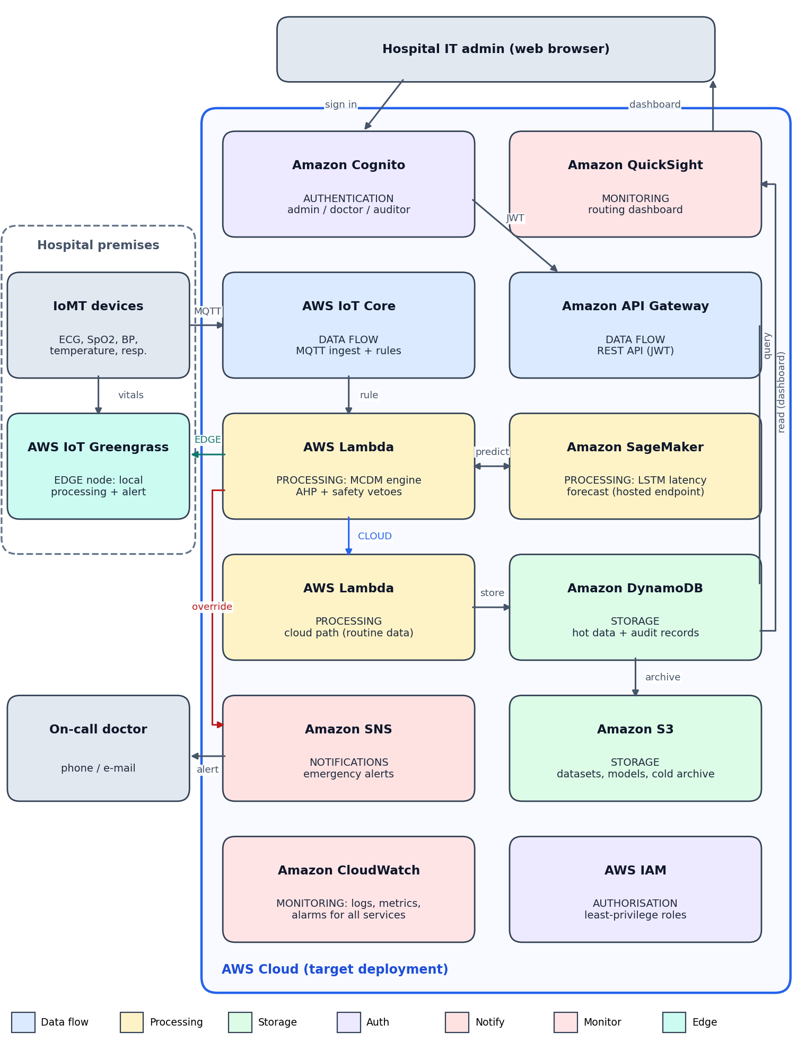
Figure 1. Proposed AWS Cloud Architecture.
Devices publish readings over MQTT to AWS IoT Core, and a local copy reaches AWS IoT Greengrass in the hospital. An IoT rule invokes the Lambda function that holds the MCDM engine. That function calls the SageMaker endpoint for the latency forecast, applies the vetoes and AHP scoring, and then sends the reading to the Greengrass edge node (EDGE) or to the cloud-path Lambda (CLOUD). The cloud path writes hot data to DynamoDB and archives to S3. Emergency overrides publish to SNS, which notifies the on-call doctor. Administrators sign in through Cognito; the JWT authorises calls through API Gateway to DynamoDB, and QuickSight shows the dashboard. IAM supplies least-privilege roles to every service, and CloudWatch collects logs, metrics and alarms.
Status: this is the target architecture. All AWS services are Planned; each has a working local stand-in described in Chapter 9.

5.3 Diagram 2 – Complete System Architecture (Mandatory)
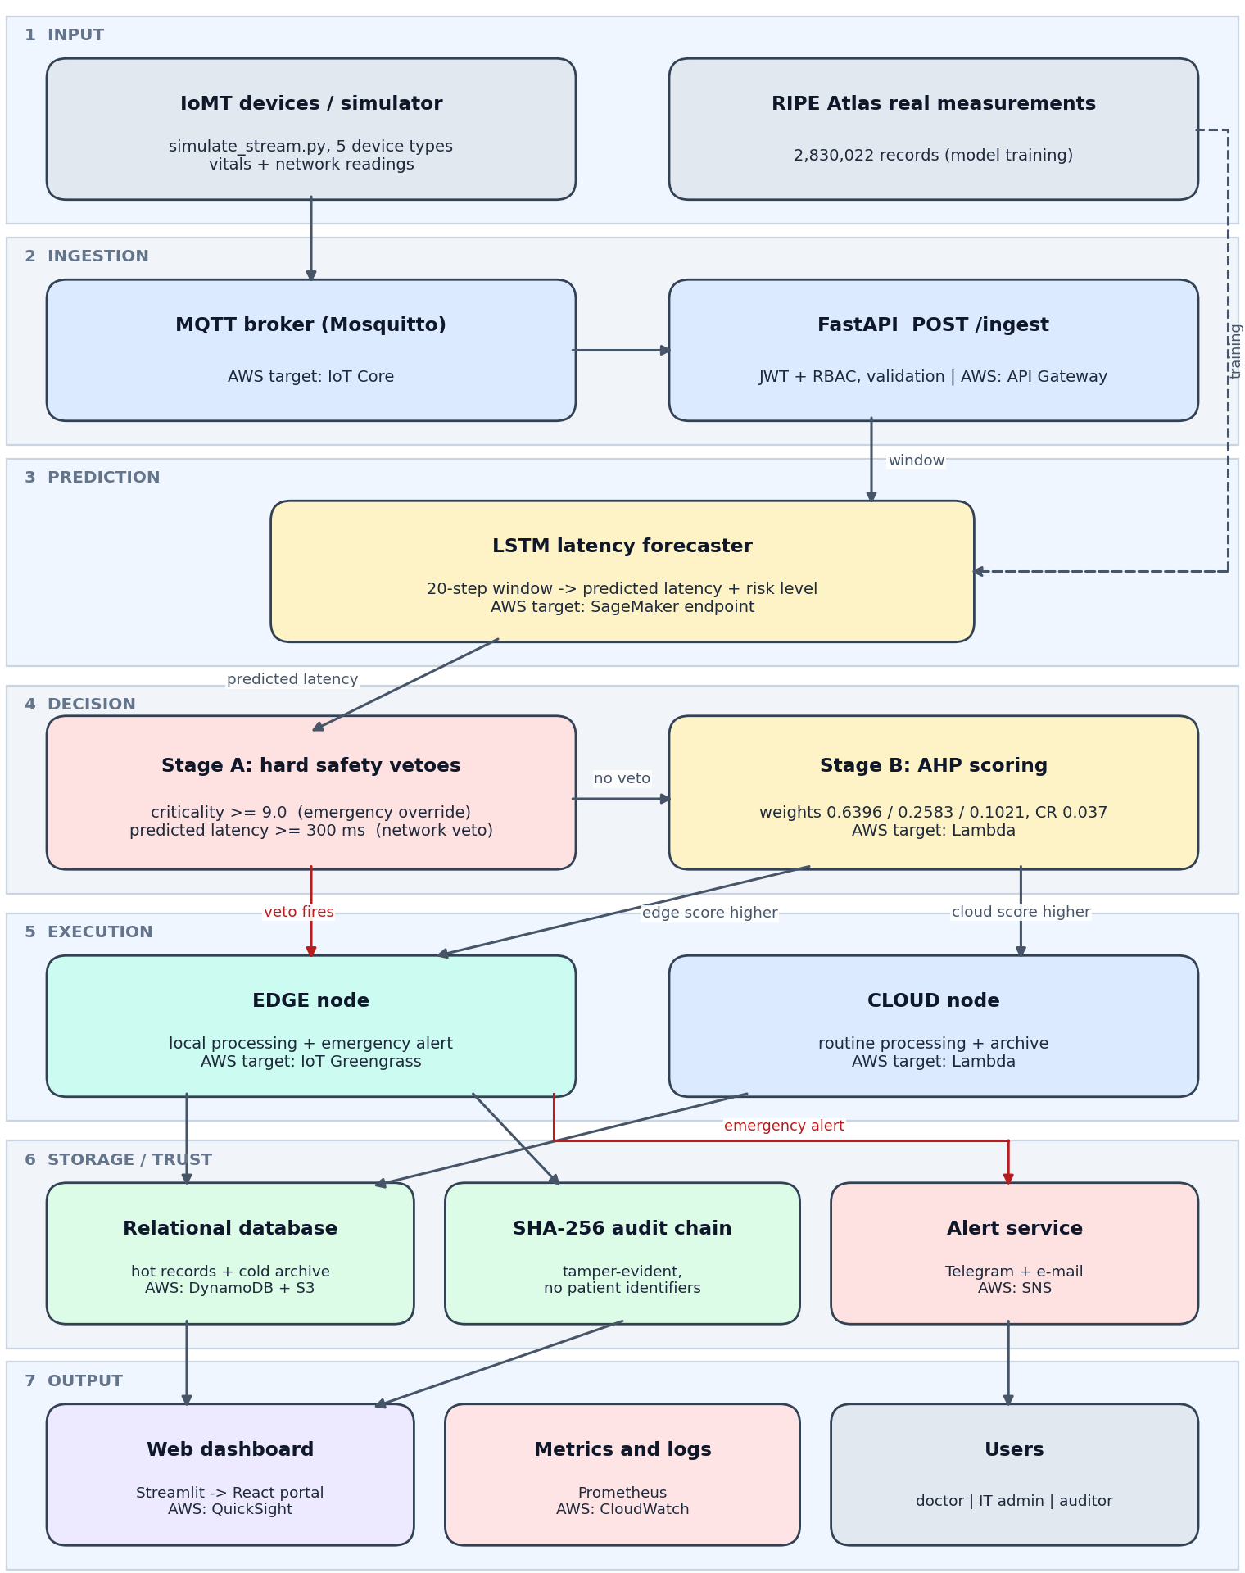
Figure 2. Complete System Architecture.
The workflow runs through seven layers.
(1) Input: IoMT devices or the stream simulator provide readings, while RIPE Atlas measurements are used to train the model.
(2) Ingestion: an MQTT broker and the FastAPI /ingest endpoint validate and authenticate each reading.
(3) Prediction: the LSTM returns a predicted latency and risk level.
(4) Decision: Stage A applies the emergency override and network veto, and Stage B applies AHP scoring.
(5) Execution: the EDGE node handles critical or unreliable-network readings locally, and the CLOUD node handles routine readings.
(6) Storage and trust: results go to the database, every decision is appended to the SHA-256 audit chain, and emergencies trigger Telegram and e-mail alerts.
(7) Output: the dashboard, metrics and users close the loop, and health metrics feed back to the dashboard. The bracketed text in the figure names the AWS service that replaces each local component.

5.4 Workflow / Use Cases
The routing workflow for one reading is shown in Figure 3.
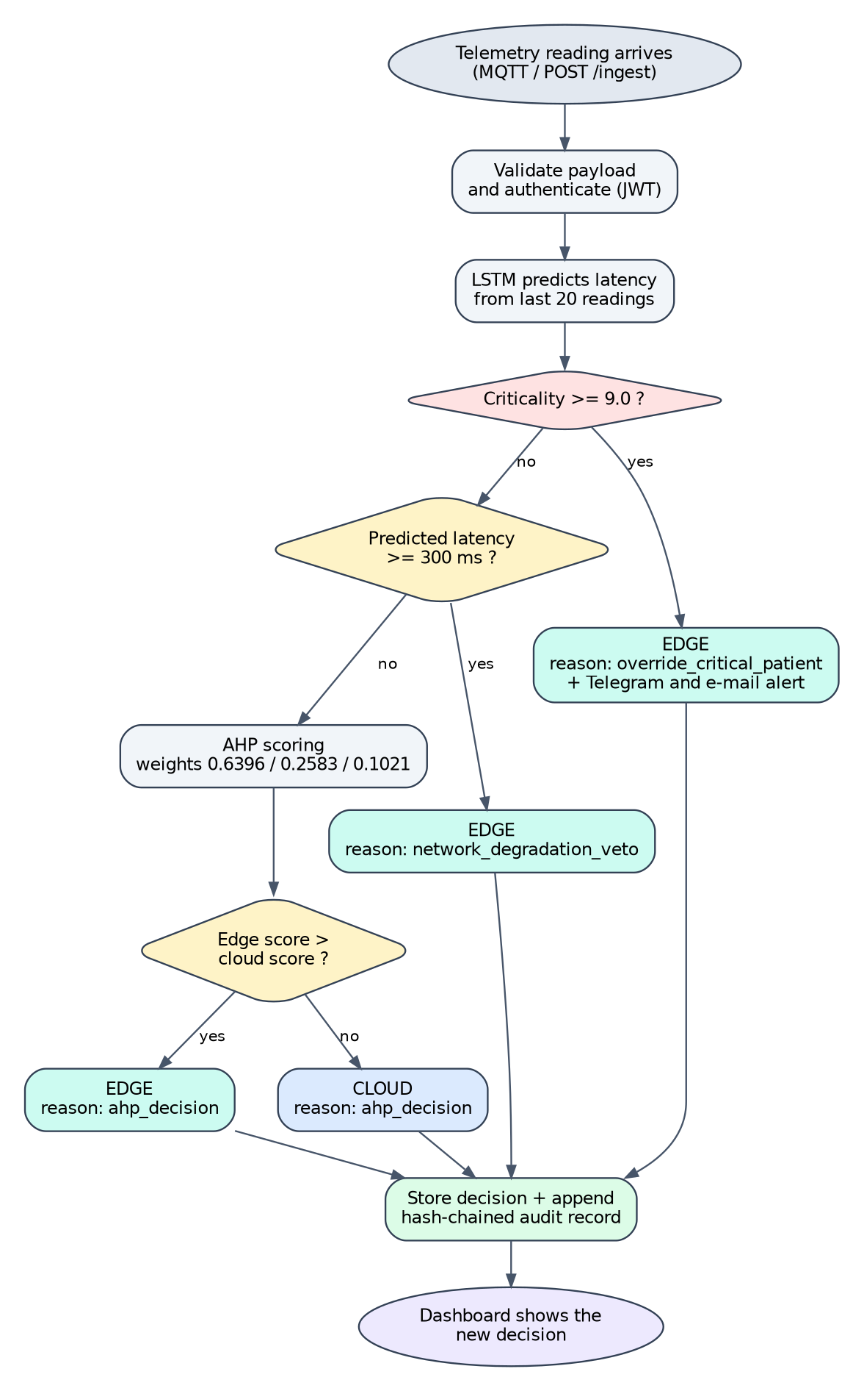
Figure 3. Routing decision flowchart for one reading.
Use case 1 – cardiac emergency: criticality 9.5 and predicted latency 210.5 ms. The emergency override fires, the reading is processed at the edge, an alert is sent and the decision is audited.
Use case 2 – routine check: criticality 0.9 and predicted latency 33.8 ms. No veto fires, AHP scoring favours the cloud, and the reading is processed and archived in the cloud.
Use case 3 – degraded network: criticality below 3 and predicted latency of 300 ms or more. The network veto fires and the reading stays at the edge even though the patient is low risk.

5.5 Security, Availability and Scalability Design
Authentication and authorisation. JWT with bcrypt-hashed passwords and three roles (admin, doctor, auditor) is implemented. On AWS this becomes Cognito user pools with IAM least-privilege roles, and MFA for administrators (Planned).
Data protection. No patient identifiers are stored, only device IDs and routing outcomes. TLS in transit and KMS encryption at rest for S3 and DynamoDB are planned for AWS; the local database is not encrypted at rest.
Audit. A SHA-256 hash-chained log makes edits to history detectable. This is a HIPAA-aligned technical safeguard [20]; it is not a compliance certification.
Network controls (Planned). Block public access on S3, VPC endpoints for S3 and DynamoDB, security groups, and Lambda inside a VPC only where a private resource requires it.
Availability and fault handling. Alerts run asynchronously so they never delay the API; the edge node keeps processing critical data if the cloud path degrades; managed services provide redundancy, and DynamoDB point-in-time recovery provides backups (Planned).
Monitoring. Prometheus metrics today; CloudWatch logs, metrics and alarms on AWS (Planned).
Scalability. The API is stateless and the AWS design uses event-driven Lambda and IoT Core, which scale automatically (Planned).

6. Dataset Description
The primary dataset is described in the table below; additional data sources follow it.
Dataset attribute | Details
Dataset name | RIPE Atlas ping measurements (network latency traces), primary training data
Source / organisation | RIPE NCC, RIPE Atlas measurement network [18]
URL | https://atlas.ripe.net
Dataset size | size in MB/GB: read from the stored file
Number of records / samples | 2,830,022 measurements
Number of features | 5 features per time step are used by the model (reported: current latency, packet loss, jitter, bandwidth, signal strength) confirm which are measured by RIPE Atlas and which are derived or simulated
Data types / format | Numeric time series; CSV / JSON
License / usage restrictions | Public measurement data under RIPE NCC terms of use confirm exact licence wording on atlas.ripe.net
Purpose in this project | Training and testing the LSTM latency forecaster
Preprocessing required | Sorting by time; Min-Max scaling; sliding windows of 20 readings; chronological train/test split
Privacy / ethical considerations | Network measurements contain no patient data. Only device IDs and routing outcomes are stored by the system, so no PHI is processed.
Additional data sources. (1) A simulated IoMT stream of 20,000 readings from five device types (simulate_stream.py) drives the live pipeline and the dashboard. (2) PhysioNet BIDMC de-identified ICU recordings (https://physionet.org/content/bidmc/) [19] are the planned source of realistic vital signs confirm whether used, and the licence on the dataset page.
Review 1 described a synthetic dataset of about 25 MB. Real RIPE Atlas data replaced it as the primary training source; synthetic data is now used to drive the simulation and for stress tests.

6.1 Data Preparation Plan
Records are sorted by time and scaled with Min-Max scaling. Sequences of 20 consecutive readings form the model input, and the next latency value is the target. The data are split chronologically (earlier data for training, later data for testing) and are not shuffled, so the model never sees the future. The scaler is fitted on training data only. Synthetic degradation events are used only for stress tests and are not mixed into training. Confirm that this matches the implemented preprocessing and add the validation split and any external test set.

7. AWS Services Planning
Status values: Planned (design only) or Configured / Tested / Deployed. At the time of writing every service is Planned; each one already has a working local stand-in, shown in the status column.
AWS service | Purpose in this project | Input/output or integration | Status | Security / cost considerations
Amazon S3 | Datasets, trained model artefacts and cold archive of routine telemetry | Written by training scripts and the cloud path; read by SageMaker | Planned (local files and cold_storage table implemented) | Block public access, SSE-KMS encryption, lifecycle to Glacier; storage cost is small
AWS Lambda (no EC2) | Runs the MCDM routing function (route_decision wrapped in lambda_handler.py) and the cloud path | Invoked by an IoT rule or API Gateway; writes to DynamoDB and S3 | Planned (handler written, not deployed) | Least-privilege execution role; pay per request, inside the always-free allowance at demo volume [25]
Amazon DynamoDB (replaces RDS) | Hot storage of telemetry, routing decisions and audit records | Written by Lambda; read by API Gateway and QuickSight | Planned (PostgreSQL / SQLite tables implemented) | Point-in-time recovery, KMS encryption, on-demand capacity
Amazon API Gateway | REST entry point for ingestion and dashboard queries | Fronts Lambda; Cognito authoriser | Planned (FastAPI /ingest implemented) | JWT authorisation, throttling, request validation
AWS IAM / Amazon Cognito | Permissions and user authentication | Cognito user pool for admin, doctor and auditor; IAM role per service | Planned (JWT, bcrypt and roles implemented) | Least privilege; MFA for admins
Amazon CloudWatch | Logs, metrics and alarms | IoT Core, Lambda and SageMaker emit metrics; alarms notify through SNS | Planned (Prometheus and structured logs implemented) | 30-day log retention; alarms on error rate and p95 latency
Amazon SNS | Emergency notifications to doctors | Published by Lambda or Greengrass on emergency override | Planned (Telegram and Gmail alerts implemented) | Topic access policy; delivery status logging
Amazon SageMaker | Train, host and version the LSTM forecaster | Reads data from S3; endpoint called by Lambda [23] | Planned (model trained locally) | Endpoints bill per hour: create for demos and delete afterwards
AWS IoT Core | MQTT ingestion from devices | Rules forward readings to Lambda [24] | Planned (Mosquitto broker implemented) | Device certificates and per-topic policies
AWS IoT Greengrass | Edge execution and local alert in the hospital | Runs the edge-node logic locally and syncs to the cloud [22] | Planned (edge node simulated locally) | Core device identity; critical data processed locally
Amazon QuickSight | Routing dashboard | Reads from DynamoDB and S3 | Planned (Streamlit dashboard implemented) | Per-user pricing; admin-only access; alternative: React portal on S3 and CloudFront
AWS KMS | Encryption keys for S3 and DynamoDB | Used by the storage services | Planned | Key policies; small monthly cost per key

7.1 AWS Deployment and Network Design
The planned region is ap-south-1 (Mumbai), closest to the users confirm region. Lambda functions run outside a VPC unless they must reach a private resource; S3 and DynamoDB are reached through VPC endpoints where a VPC is used. Secrets are kept in environment variables and AWS Systems Manager Parameter Store or Secrets Manager, never in the repository. Deployment will use GitHub Actions with the AWS CLI or AWS SAM. Access boundaries: no use of the root account, MFA on administrators, one IAM role per service with only the actions it needs, and separate roles for the three user types. The local Docker Compose stack remains the development and test environment.

7.2 Cost Estimation
Assumptions. Five devices send one reading every 20 seconds, about 21,600 readings per day or roughly 650,000 per month. Lambda would see about 650,000 invocations plus a few thousand dashboard calls, below the always-free allowance of 1 million requests per month [25]. DynamoDB storage stays far below the 25 GB always-free limit, S3 holds under 1 GB, SNS carries only emergency messages, and CloudWatch logs stay below 1 GB.
Estimate. About USD 5–15 per month for the demonstration configuration, dominated by IoT Core messages, CloudWatch and SageMaker usage. For accounts created after 15 July 2025 the Free plan gives USD 100 in credits (up to USD 200) for six months, which is expected to cover the demonstration [25]. The main cost risk is a SageMaker real-time endpoint left running all month; endpoints will be created only for demonstrations and deleted afterwards.
Pricing source and date. AWS Free Tier description on AWS Builder Center (last updated 6 May 2026) [25] and the public AWS pricing pages checked in October 2026 verify the figures in the AWS Pricing Calculator on the deployment date. Cost control. AWS Budgets alerts at 50%, 80% and 100% of a USD 20 limit, no EC2, deletion of idle resources, on-demand capacity. This is a planning estimate, not an actual bill.

8. Methodology and Implementation Plan

8.1 Overall Methodology
The project followed seven phases: requirements and success criteria; literature review and research gap; data acquisition (RIPE Atlas) and the simulated stream; architecture design and AWS service mapping; implementation of the prediction, decision, execution, alert, audit and dashboard components; integration with REST and MQTT; and testing with continuous integration. A local-first strategy was used: every AWS service has a local stand-in with the same interface, so the logic can move to AWS by replacing adapters. Decision weights were derived with AHP [16], and the forecaster is an LSTM [17].

8.2 Tools and Technologies
Tool / technology | Purpose | Version / configuration
AWS services (target) | IoT Core, Greengrass, Lambda, SageMaker, API Gateway, DynamoDB, S3, SNS, Cognito, IAM, CloudWatch, QuickSight | Region ap-south-1 planned confirm; nothing deployed yet
Programming language / framework | Python; FastAPI for the REST API; SQLAlchemy 2.0 and Alembic for the database | FastAPI 0.111 as planned add Python and library versions from requirements.txt
Database / ML framework / other tools | TensorFlow/Keras LSTM; PostgreSQL (Neon.tech) with SQLite for local use confirm which database backs the demo; Redis; Mosquitto MQTT; Prometheus; Streamlit and Plotly; Docker Compose | versions
Alerting | Telegram Bot API and Gmail SMTP (stand-in for SNS) | Credentials kept in environment variables only
Testing and CI | pytest (99 tests reported); GitHub Actions with lint, test and Docker build jobs | Locust load test planned
Git and GitHub | Version control and collaboration | Repository: https://github.com/itscharles4/AI-Based-Multi-Cloud-Migration-Decision-Framework-for-Healthcare-Enterprises; branches main, develop, feature/student1, feature/student2, feature/student3

8.3 Step-by-Step Implementation Plan
Step 1 – Requirements and success criteria: routing requirements (critical alerts stay local, routine data goes to the cloud, every decision is auditable) and the measurable objectives of Chapter 3. Status: done.
Step 2 – Dataset or input preparation: RIPE Atlas measurements collected through its API, a five-device simulated stream built, Min-Max scaling and 20-reading windows prepared. Status: done; accuracy evaluation pending.
Step 3 – Architecture and AWS resource setup: two architecture diagrams and the service mapping designed (Figures 1 and 2). Status: design done; AWS account, budget alerts and IAM setup planned.
Step 4 – Application / backend / model development: LSTM forecaster, AHP engine, execution layer, API, database, alerts, audit log and dashboard. Status: implemented locally.
Step 5 – Integration and security configuration: layers connected through FastAPI and MQTT; JWT, roles and audit chain added; Docker Compose stack. Status: implemented; check that no secrets are in the Git history still pending.
Step 6 – Testing and performance evaluation: unit and integration tests (99 reported) and CI. Planned: Locust load test and baseline comparison. Status: partly done.
Step 7 – Deployment, monitoring and documentation: Prometheus now; planned Lambda, SageMaker and IoT Core deployment with CloudWatch; this report, README and presentation. Status: documentation in progress; AWS deployment planned.

8.4 Evaluation Metrics
- Forecast accuracy: MAE and RMSE on a chronological held-out set, compared with a persistence baseline and an exponentially weighted average; precision and recall for latency spikes above the veto threshold.
- Routing correctness: share of override and veto cases routed to the edge (target 100%); share of routine cases sent to the cloud.
- Response time and throughput: p50 and p95 latency of POST /ingest and requests per second at 10, 50 and 200 concurrent users (target p95 below 200 ms), measured with Locust.
- Alert delivery: time from emergency override to delivered Telegram and e-mail message, and the delivery success rate.
- Integrity and availability: audit-chain verification result after a deliberate tamper test; successful requests divided by total requests during the load test.
- Cost: monthly estimate compared with the budget limit.

9. Implementation / Development
Completed work and planned work are listed separately in the table. Screenshots are dated and contain no secrets, tokens or personal data.

9.1 Implemented Modules
Module | Implementation details | AWS services / tools | Evidence (figure, commit, PR) | Status
Prediction layer (LSTM) | Two-layer stacked LSTM (64 and 32 units) that predicts the next latency from a 20-reading window; trained on 2,830,022 RIPE Atlas records; risk levels LOW, MEDIUM, HIGH confirm LSTM vs BiLSTM; the dashboard labels it BiLSTM | TensorFlow/Keras; AWS target: SageMaker, S3 | src/ml_model; training output commit / PR links | Implemented; accuracy metrics pending  [CHARLES]
Decision engine | AHP weights and consistency ratio 0.037; emergency override (criticality of 9.0 or more); network veto (latency of 300 ms or more); decision unit tests | Python; AWS target: Lambda | src/backend decision module; test report commit / PR links | Implemented  [Tanmay Kapoor]
Execution layer | Edge node, cloud node, hot and cold storage, MQTT consumer and REST API (/ingest, /health, /stats, history) | FastAPI, MQTT, Redis; AWS: Greengrass, Lambda, API Gateway, DynamoDB, S3 | src/aws and src/backend; Figures 4–7 | Implemented locally[CHARLES]
Authentication and audit | JWT with bcrypt and roles (admin, doctor, auditor); SHA-256 hash-chained audit log; no patient identifiers stored | PyJWT, bcrypt; AWS: Cognito, IAM | Automated tests commit / PR links | Implemented[RANI GUPTA]
Alert service | Telegram bot and Gmail SMTP alerts on emergency override, sent asynchronously | AWS: SNS | Reported live test add screenshot of delivered messages | Implemented; delivery log pending [RANI GUPTA]
Dashboard | Key metrics, latency trend, routing split, criticality scatter, decision reasons, alert feed, events table, simulator control | Streamlit, Plotly; AWS: QuickSight | Figures 4–7 | Implemented (prototype)[RANI GUPTA]
Monitoring, CI and containers | Prometheus metrics; Docker Compose stack; GitHub Actions with lint, test and Docker build jobs | AWS: CloudWatch, CodePipeline | CI run add link | Implemented; Grafana dashboards pending[RANI GUPTA]
Lambda handler | lambda_handler.py wraps the routing function so the same logic can run on AWS Lambda | AWS Lambda | Repository file commit link | Written; not deployed[CHARLES]
AWS deployment | S3, Lambda, SageMaker, IoT Core, DynamoDB, SNS, Cognito, CloudWatch | AWS | None yet | Planned[CHARLES]

9.2 Screenshots and Configuration Evidence
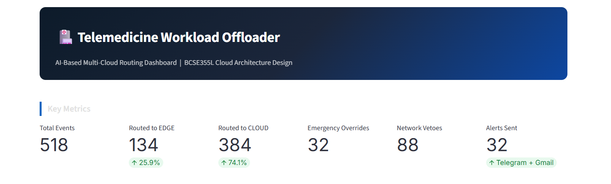
Figure 4. Dashboard key metrics (15 October 2026): 518 events, 134 routed to EDGE (25.9%), 384 to CLOUD (74.1%), 32 emergency overrides, 88 network vetoes and 32 alerts.
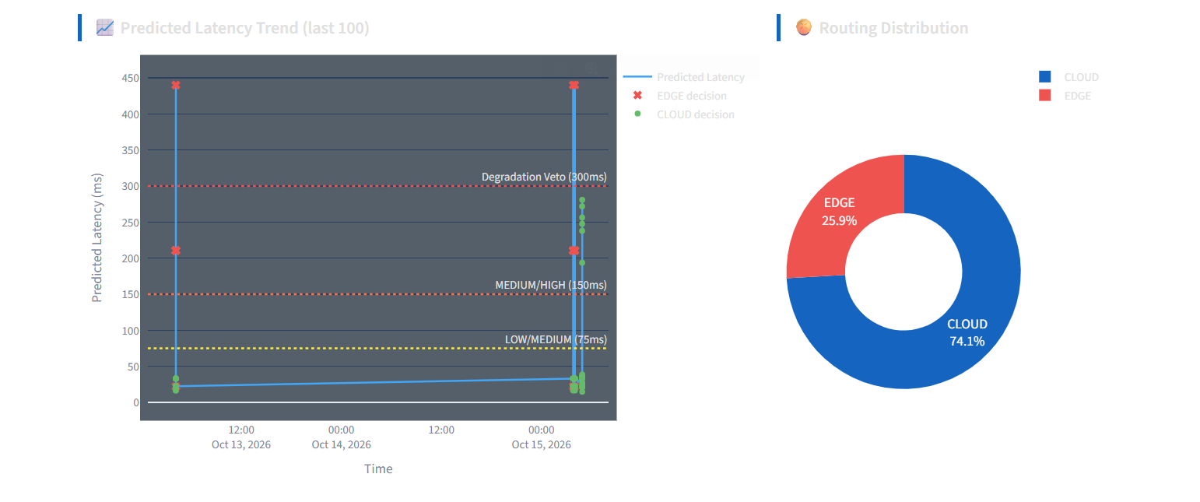
Figure 5. Predicted latency trend with the 75, 150 and 300 ms thresholds, and the EDGE and CLOUD routing distribution.
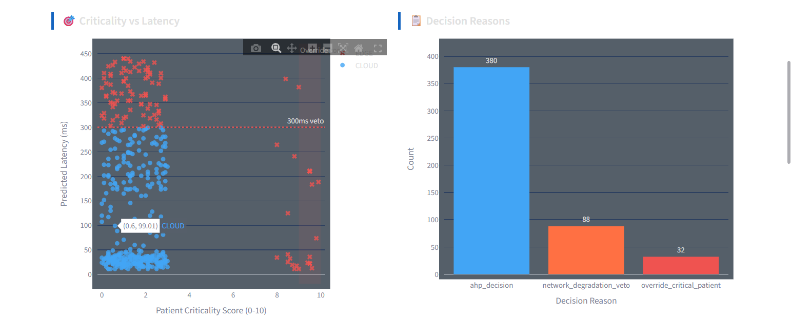
Figure 6. Criticality versus predicted latency (EDGE points above the 300 ms line and in the override zone) and the decision-reason counts.
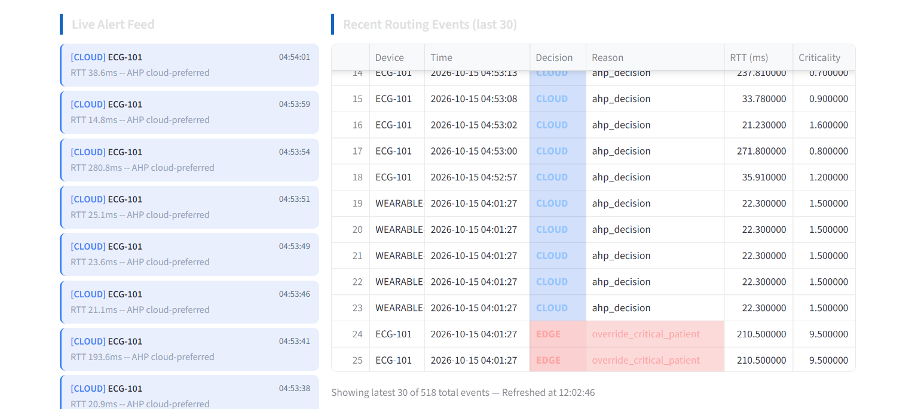
Figure 7. Live alert feed and recent routing events with device, decision, reason, latency and criticality.
The screenshots show the Streamlit prototype dashboard processing simulated events; they contain no credentials or personal data. Some rows are repeated test events, which is one reason a cleaner demonstration dataset is planned.

9.3 GitHub Repository
Repository: https://github.com/itscharles4/AI-Based-Multi-Cloud-Migration-Decision-Framework-for-Healthcare-Enterprises (current name). The guideline name format is ProjectName_Cloud_Project_2026, so the repository will be renamed to Telemedicine_Cloud_Project_2026 rename the repository and update the URL before submission. The structure below follows the guideline, with the student responsible for each part.
Repository structure and task allocation:
- README.md, LICENSE, .gitignore – overview, how to run, branch rules and task allocation (README: Student 3; LICENSE, .gitignore and requirements: Student 2)
- docs/ – Project_Report, Literature_Survey, Research_Gap (one file per student), Objectives, Novelty
- architecture/ – AWS_Architecture.png, System_Architecture.png and Workflow.png (Figures 1–3)
- dataset/ – raw/ and processed/ (RIPE Atlas extracts where licensing permits) and dataset_description.pdf (Student 1)
- src/ml_model/ – preprocessing, training, prediction and the saved model (Student 1)
- src/backend/ – decision engine: AHP, override and veto rules, tests (Student 2); API, database, authentication and MQTT consumer (Student 3)
- src/aws/ – edge node, cloud node, alert service, audit log, logging and IAM notes (Student 3); lambda_handler.py (Student 2)
- src/frontend/ – dashboard (Student 3)
- results/ – graphs, screenshots, accuracy.xlsx: model results (Student 1), routing-distribution chart (Student 2), integration and load-test results (Student 3)
- presentation/ – review slides (all students)
Branches: main ← develop ← feature/student1 (Charles), feature/student2 (Tanmay Kapoor), feature/student3 (Rani Gupta). Each student works only in their own feature branch and raises pull requests into develop.

10. Testing, Results and Observations

10.1 Test Plan and Test Cases
Test ID | Scenario | Input / setup | Expected result | Observed result | Pass/Fail
T01 | Emergency override | Criticality 9.5, predicted latency 210.5 ms (ECG-101) | EDGE, reason override_critical_patient | EDGE, override_critical_patient (events table, 15 Oct 2026, Figure 7) | Pass
T02 | Routine reading | Criticality 0.9, latency 33.8 ms | CLOUD, reason ahp_decision | CLOUD, ahp_decision (Figure 7) | Pass
T03 | Network veto | Low criticality (below 3) with predicted latency of 300 ms or more | EDGE, reason network_degradation_veto | 88 network-veto events; in the scatter plot every low-criticality point above 300 ms is EDGE (Figure 6) | Pass
T04 | Decision-reason accounting | Reasons chart compared with total events | Reason counts add up to the total | 380 + 88 + 32 = 500 against 518 total events | Fail (open)
T05 | Authentication and roles | Wrong password; auditor attempting an admin action | Request rejected | Covered by the automated suite reported in CI attach test output | Reported
T06 | Audit-chain tamper test | Modify a stored audit record, then verify the chain | Verification fails at the modified record | Covered by automated tests attach output or demonstrate live | Reported
T07 | Emergency alerts | Emergency override event | Telegram and e-mail message delivered | Reported working in a live test; dashboard shows 32 alerts, equal to the override count add delivery screenshots | Reported
T08 | Automated test suite | pytest in GitHub Actions | All tests pass | 99 of 99 passing as reported add CI run link | Reported
T09 | Performance (p95 below 200 ms) | Locust at 10, 50 and 200 users | p95 below 200 ms | Not yet run (load-test script pending) | Not run
T10 | Scalability burst | Many concurrent device streams | No failed requests; stable latency | Not yet run | Not run

10.2 Results
The table gives the measured values shown on the dashboard on 15 October 2026 (Figures 4–6). The events are simulated, so the percentages describe the test stream, not real hospital traffic.
Metric | Value | Evidence
Total routing events | 518 | Figure 4
Routed to EDGE | 134 (25.9%) | Figures 4, 5
Routed to CLOUD | 384 (74.1%) | Figures 4, 5
Emergency overrides (criticality of 9.0 or more) | 32 | Figures 4, 6
Network vetoes (predicted latency of 300 ms or more) | 88 | Figures 4, 6
Decision reasons: ahp_decision / network_degradation_veto / override_critical_patient | 380 / 88 / 32 (sum 500) | Figure 6
Alerts sent (as displayed; equals the override count) | 32 | Figure 4
AHP consistency ratio | 0.037 (limit 0.10) | Decision-engine design
Automated tests passing in CI | 99 of 99 (reported) | CI run add link

Forecast accuracy (MAE, RMSE), response-time percentiles and alert delivery times have not been measured yet and are therefore not reported here. Insert the LSTM held-out MAE and RMSE and the baseline values from the training run.

10.3 Baseline Comparison
Not yet evaluated. Planned experiment: replay the same stream of readings through (a) the proposed engine, (b) a fixed-threshold baseline that routes to the edge when latency exceeds 100 ms or criticality exceeds 9, and (c) an always-cloud policy. Compare critical events delayed beyond 300 ms, the share of data sent to the cloud (a cost proxy) and agreement with the safety rules. For the forecaster the baselines are a persistence model (next latency equals current latency) and an exponentially weighted average, compared on MAE and RMSE under identical splits.

10.4 Results Summary
Objective 1 (forecasting): model trained on 2,830,022 records; accuracy figures not yet reported.
Objective 2 (routing): consistency ratio 0.037; override and veto cases observed routed to the edge (T01, T03, Figures 6–7); the decision-reason accounting defect (T04) is open.
Objective 3 (response time): not yet evaluated (T09).
Objective 4 (alerts): implemented and reported working; delivery time and log pending (T07).
Objective 5 (security and audit): implemented; tamper-test evidence pending (T05, T06).
Objective 6 (dashboard and AWS): dashboard evidenced in Figures 4–7; AWS deployment planned.

11. Discussion, Limitations and Risk Analysis

11.1 Discussion
The dashboard run shows the engine behaving as designed on the test stream: emergency readings and degraded-network readings are routed to the edge, and routine readings go to the cloud, with about a quarter of events kept at the edge. This matters because it keeps life-critical data local while still sending most routine data to the cloud, which is the trade-off the project set out to automate. The findings are encouraging but limited: they come from simulated events, and forecast accuracy and response time are not yet measured.

11.2 Limitations
- The system is a research prototype. It has not been validated clinically, and the criticality scale and the thresholds of 9.0 and 300 ms are design parameters that need clinical review before any real use.
- Only simulated and public data are used, and the simulated criticality values cluster at low and high ends with few mid-range cases.
- The design follows HIPAA-aligned principles but is not certified; TLS, encryption at rest, MFA and formal risk assessment are planned, not done.
- The AWS migration is designed and a Lambda handler is written, but no service is deployed on AWS yet.
- Forecast accuracy against baselines, load-test results and alert delivery times have not been measured.
- Known defects: decision-reason counts (500) differ from total events (518); the dashboard contains repeated test rows; the Alerts Sent figure counts overrides rather than confirmed deliveries.
- The network veto depends on the forecast; a fallback to measured latency when the model is unavailable is planned but not yet built.
- The dashboard reads the database directly and is a prototype; a role-based React portal that reads through the API is planned.

11.3 Risks and Mitigation
Risk | Likelihood / impact | Mitigation | Residual risk
Unexpected AWS cost | Medium / Medium | AWS Budgets alerts, delete the SageMaker endpoint after demos, no EC2, use Free plan credits | Low
Credential exposure / misconfiguration | Medium / High | Keep .env out of Git, use environment variables or Secrets Manager, IAM least privilege, rotate tokens, scan the Git history before submission | Low once the scan is done pending
Dataset quality / availability | Medium / Medium | Validate and clean data, keep a local copy of downloaded measurements, use the simulated stream as a fallback | Low
Forecaster unavailable or inaccurate | Medium / High | The emergency override does not use the model; add a fallback to measured latency for the network veto | Medium until the fallback is built
Test or duplicate rows distort dashboard counts | High / Low | Add a source flag (live, simulated, test) and a unique key on device and timestamp; hide test data by default | Low

12. Team Contribution and GitHub Management
Responsibilities were refined after Review 1. The decision engine remained with Student 2, while the REST API, hot-storage layer and dashboard (listed under Student 2 in Review 1) were built as part of the execution layer by Student 3, together with edge and cloud nodes, authentication, alerts and the audit log. This keeps each student's work aligned with their Review 1 focus: Student 1 AI and data, Student 2 MCDM, Student 3 execution and security.
Activity | Student 1 | Student 2 | Student 3
Literature survey and assigned paper analysis | Papers P1–P5 (network prediction, edge AI, forecasting) | Papers P6–P10 (offloading, DQN and DRL, SmartVSO) | Papers P11–P15 (edge latency, cold starts, HIPAA architectures, EHR logs, microservices)
Research gap and novelty | Gaps on lightweight predictive models and anomaly pairing; predictive-routing novelty | Gaps on fixed rules and limited evaluation; AHP and override novelty | Gaps on hybrid sync, compliance and serverless versus containers; edge–cloud security novelty
Frontend / application | Provides model results and accuracy graphs for the dashboard | Provides the decision explanation output for the dashboard | Dashboard: login, metrics, charts, alerts and audit views (Streamlit now, React portal planned)
Backend / APIs / database | Prediction service function (predict_latency) | Decision engine library (AHP, vetoes, router) and Lambda handler wrapper | FastAPI API (/ingest, /health, /stats, history), database and storage layer, MQTT consumer, Redis
AWS services and security | S3 (datasets), SageMaker and IoT Core ingestion plans | Lambda (routing function) | Greengrass edge node, Lambda cloud path, Cognito and IAM, CloudWatch, SNS and alerts, DynamoDB mapping, JWT roles, audit chain
Dataset / AI-ML (if applicable) | RIPE Atlas ingestion, preprocessing, LSTM training and evaluation, stream simulator | Not applicable | Not applicable
Testing and results | Model evaluation (MAE, RMSE) and graphs | Decision-engine unit tests and routing-distribution chart | Integration, API, authentication and audit tests; CI; Locust load test
Documentation and presentation | Dataset description, AI section, results graphs | Decision-engine section, LICENSE, .gitignore, requirements, decision-engine slides | README and repository structure, architecture diagrams, security and deployment sections, dashboard slides

12.1 Branch and Pull Request Workflow
The repository uses main (stable), develop (integration) and one feature branch per student: feature/student1, feature/student2 and feature/student3. Nobody commits directly to main or develop. Each student commits regularly to their own branch, raises a pull request into develop, and a teammate reviews it before merging. Merge conflicts are resolved in the pull request by the author. When develop is stable it is merged into main and the release is tagged (for example v1.0-Phase1).

12.2 Contribution Evidence
The guideline expects about 20–30 meaningful commits per student, at least two pull requests, code-review participation and regular weekly commits. The table must be completed from the repository history; entries marked in yellow are not yet filled.
Student | GitHub username | Branch | Key commits and pull requests | Code reviews
Student 1 – Charles Jehanabad (24BIT0522) | itscharles4 (repository owner) confirm | feature/student1 | add commit count and PR links | add
Student 2 – Tanmay Kapoor (24BIT0079) | add username | feature/student2 | add commit count and PR links | add
Student 3 – Rani Gupta (24BIT0543) | add username | feature/student3 | add commit count and PR links | add

13. Conclusion and Future Enhancements

13.1 Conclusion
The project set out to decide, for every IoMT reading, whether processing should happen at the hospital edge or in the cloud. We built a pipeline that forecasts network latency with an LSTM trained on 2,830,022 real RIPE Atlas measurements, applies two hard safety vetoes and an AHP score (consistency ratio 0.037), executes the decision on an edge or cloud node, alerts clinicians in emergencies and records every decision in a hash-chained audit log, with a dashboard and 99 automated tests reported in CI. A dashboard run of 518 simulated events routed 25.9% to the edge and 74.1% to the cloud, including 32 emergency overrides and 88 network vetoes. Objectives 2, 4, 5 and 6 are largely met on the local implementation. Forecast accuracy against baselines, response-time measurements and AWS deployment are not yet evidenced and are the next steps.

13.2 Future Enhancements
- Migrate to AWS one service at a time: S3, Lambda, SageMaker, IoT Core and Greengrass, DynamoDB, SNS, Cognito, CloudWatch, then QuickSight or a React portal on S3 and CloudFront.
- Measure forecast accuracy against baselines, run the Locust load test and compare the engine with a fixed-threshold policy on identical events.
- Run a sensitivity analysis of the AHP weights and the 9.0 and 300 ms thresholds.
- Add a fallback to measured latency when the forecaster is unavailable, and an alert delivery log.
- Build a role-based React portal (sign-in, alerts, audit verification, decision explainer) that reads through the API.
- Strengthen HIPAA-aligned safeguards: TLS, KMS encryption, MFA and access logging.
- Replace the illustrative criticality score with a clinician-approved early-warning protocol and validate it.
- Extend the framework to choose between several cloud providers, as the project title suggests.

References
References follow APA style. Entries [1]–[15] are the reviewed papers in the order P1–P15; fields marked in yellow must be completed from the publisher record.
[1] Deep Learning for Network Congestion Prediction in Healthcare IoT. (2025). IEEE. authors, journal, volume(issue), pages, DOI
[2] Edge-AI in Remote Patient Monitoring Systems. (2024). Elsevier. authors, journal, volume(issue), pages, DOI
[3] Spatiotemporal Forecasting for Hospital Wi-Fi Reliability. (2026). Springer. authors, journal, volume(issue), pages, DOI
[4] Energy-Efficient AI Workload Offloading in Wearables. (2025). MDPI. authors, journal, volume(issue), pages, DOI
[5] Traffic Classification of Telemedicine Video Streams. (2023). IEEE. authors, journal, volume(issue), pages, DOI
[6] A framework for offloading and migration of serverless functions in the Edge–Cloud Continuum. (2024). Elsevier. authors, journal, volume(issue), pages, DOI
[7] Energy-Aware Tasks Offloading Based on DQN in Medical Mobile Devices. (2024). Springer. authors, journal, volume(issue), pages, DOI
[8] Resource Allocation and Data Offloading Strategy for Edge-Computing-Assisted Intelligent Telemedicine System. (2023). MDPI. authors, journal, volume(issue), pages, DOI
[9] DRL-Based Dependent Task Offloading with Delay-Energy Trade-off in Medical Image Edge Computing. (2025). publisher / venue, authors, volume(issue), pages, DOI
[10] Towards providing a priority-based vital sign offloading in healthcare with serverless computing and a fog-cloud architecture (SmartVSO). (2024). Elsevier. authors, journal, volume(issue), pages, DOI
[11] Performance Analysis of Edge … complete title, year, publisher, authors, DOI
[12] Cold Start Mitigation in Serverless Functions for Healthcare APIs. (2026). ACM. authors, venue, volume(issue), pages, DOI
[13] HIPAA-Compliant Architectures in Multi-Cloud Environments. (2024). Springer. authors, journal, volume(issue), pages, DOI
[14] Blockchain vs. Serverless for EHR Access Logs. (2025). Elsevier. authors, journal, volume(issue), pages, DOI
[15] Scalability of Microservices in Telehealth Platforms. (2026). Wiley. authors, journal, volume(issue), pages, DOI
[16] Saaty, T. L. (1980). The analytic hierarchy process: Planning, priority setting, resource allocation. McGraw-Hill.
[17] Hochreiter, S., & Schmidhuber, J. (1997). Long short-term memory. Neural Computation, 9(8), 1735–1780. https://doi.org/10.1162/neco.1997.9.8.1735
[18] RIPE NCC Staff. (2015). RIPE Atlas: A global Internet measurement network. Internet Protocol Journal, 18(3), 2–26. Data portal: https://atlas.ripe.net
[19] Goldberger, A. L., Amaral, L. A. N., Glass, L., Hausdorff, J. M., Ivanov, P. C., Mark, R. G., Mietus, J. E., Moody, G. B., Peng, C.-K., & Stanley, H. E. (2000). PhysioBank, PhysioToolkit, and PhysioNet: Components of a new research resource for complex physiologic signals. Circulation, 101(23), e215–e220. https://doi.org/10.1161/01.CIR.101.23.e215
[20] U.S. Department of Health and Human Services. (n.d.). The HIPAA Security Rule. https://www.hhs.gov/hipaa/for-professionals/security/index.html
[21] Amazon Web Services. (n.d.). AWS Lambda developer guide. https://docs.aws.amazon.com/lambda/
[22] Amazon Web Services. (n.d.). AWS IoT Greengrass developer guide. https://docs.aws.amazon.com/greengrass/
[23] Amazon Web Services. (n.d.). Amazon SageMaker developer guide. https://docs.aws.amazon.com/sagemaker/
[24] Amazon Web Services. (n.d.). AWS IoT Core developer guide. https://docs.aws.amazon.com/iot/
[25] AWS Builder Center. (2026, May 6). Everything you need to know to get started with AWS Free Tier. https://builder.aws.com/content/3BlPcDGddaB6WkPvUf1LIy1rzIm/everything-you-need-to-know-to-get-started-with-aws-free-tier

Appendix A – Project Timeline
Phase / task | Planned start | Planned end | Owner(s) | Status / evidence
Literature survey | start date | 30/07/2026 | Charles (P1–P5), Tanmay (P6–P10), Rani (P11–P15) | Completed – Review 1 document
Research gap and novelty | start date | 30/07/2026 | All three students | Completed – Review 1 document
Architecture design | start date | end date | Rani (lead), Charles, Tanmay | Figures 1–3 redrawn for this report
Implementation and integration (local prototype) | start date | 13/10/2026 | All three students | Local prototype reported complete on 13/10/2026
Real-data, database, alerts and dashboard upgrade | 13/10/2026 | 15/10/2026 | All three students | RIPE Atlas training data, database, alerts, CI, dashboard (Figures 4–7)
Testing and report | start date | end date | All three students | Chapter 10; load test and baseline comparison pending
AWS migration and evaluation | planned start | planned end | Charles (S3, SageMaker), Tanmay (Lambda), Rani (Greengrass, IoT Core, Cognito, CloudWatch, SNS) | Planned

Appendix B – Review Checklist
☑ Abstract is 200–300 words and describes the problem, challenges, proposed solution, AWS services, and status/results.
☐ 15 research papers are included, with citations and a comparative literature survey. Pending: authors, volume and DOI for P1–P15; incomplete P9 and P11.
☑ Each student has completed their own research gap analysis for assigned papers.
☑ 4–6 measurable objectives are listed.
☑ Novelty summary is limited to about one page and is supported by comparison with existing work.
☑ Both required architecture diagrams are included and explained.
☐ Dataset name, source, URL, size, record count, feature count, data type, license, purpose, and preprocessing are documented where applicable. Pending: dataset size, feature provenance and licence confirmation.
☑ AWS services, their purpose, status, security considerations, and estimated cost are documented.
☐ Implementation evidence, test cases, actual results, limitations, and future work are included. Pending: commit and PR links, CI run link, accuracy and load-test results.
☐ GitHub repository, branch workflow, pull requests, commits, and individual contributions are documented. Pending: repository rename and per-student commit evidence.
☐ References use APA style; all borrowed ideas, figures, datasets, and documentation are cited. Pending: complete APA entries for [1]–[15].
☐ No credentials, passwords, tokens, or confidential data appear in the report or repository. Report is clean; Git history scan still to be done.
☐ Report follows the specified font, spacing, margin, heading, and page-number formatting. Check after final edits.

